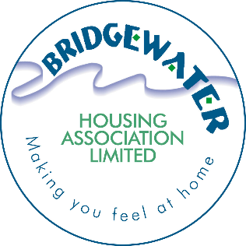

Bridgewater Housing Association Strategy
Policy name | Equality, Diversity, and Inclusion Strategy
Policy category | Corporate (Governance/HR)
Policy number | CS19
Date adopted | 6 March 2024
Last review | n/a
This review | 6 March 2024
Next review | March 2027
Equalities impact assessment required | Yes – Policy
Equalities impact assessment completed | February 2024
Links to other documents | Equalities, Diversity & Inclusion Policy.  Business Plan 2023 to 2028
Consultation | Yes – Public Consultation during Jan-Feb 2024
Need for Procedure | No
Policy Owner | Chief Executive

Bridgewater Housing Association (BHA)
Equality, Diversity, and Inclusion (EDI) Strategy

This policy can also be provided in large print, braille, audio, or other non-written format and in a variety of languages on request. Please contact the Association by emailing admin@bridgewaterha.org.uk or call 0141 812 2237 to request this.

Contents
1. Leadership Message 3
2. Introduction 3
3. Purpose of Strategy 4
4. Our Vision 4
5. Strategic EDI Objectives 4
6. EDI Goals 4
7. Roles and Responsibilities 5
8. Resources 5
9. Monitoring And Review 5
Appendix 1 - Equality and Diversity Monitoring: What do we know? 8
Appendix 2: Action Plan 2023-2026 (draft 06/12/2023) 16

1. Leadership Message

1.1 The EDI strategy is designed to deliver our vision of “a customer focussed organisation that delivers the best affordable housing and services to people who need them most” and we aspire to lead the way in achieving this.
1.2 One of our Strategic Objectives in the Business Plan outlines a commitment to “Doing what matters most, with and for, our customers”. This can only be done with a shared understanding and a belief in creating an environment where all of our people, from staff to customers to board members, embrace opportunities to learn from one another and from a wider range of diverse communities and individuals.
1.3 Leadership is key to the successful delivery of the EDI agenda and plays a vital role in recognising and facilitating it across Bridgewater Housing Association’s functions, both as employer and as service provider. The Board and leadership team will ensure that equality, diversity, and inclusion is central to the business and planning process and that it is embedded in our core strategy, policies, and procedures.

2. Introduction

2.1 The Equality Act 2010 is very clear about what it expects organisations to do, but legislation can only be meaningful if it is delivered with clear objectives, commitment and if it has a positive impact on the culture of the organisation.
2.2 We will progress from our current position and support our staff to do their jobs, and our customers to access our services, without barriers. Our services are fair and equal, and our stakeholders and partners not only acknowledge our commitment but work with us in the delivery of our EDI strategy. We will keep an open mind on new initiatives or requirements needing attention to ensure that these can be integrated into the strategy and delivered.
2.3 Equality is not about treating everyone the same – it is about recognising and embracing differences and proactively adapting our approach so that the outcome for each person is the same. We recognise that there are specific groups and individuals in society who experience discrimination, harassment, and exclusion because of different aspects of their identity. This can have a profound impact on their lives and adversely affect the opportunities open to them. BHA is committed to proactively tackling this discrimination and disadvantage. We know good housing is a basic human need. It provides the foundation for good health and opportunities for individuals and contributes to sustainable places and quality of life for communities. So, we play a vital part in ensuring welfare, protection, and access to opportunities.

3. Purpose of Strategy

3.1 Our Equalities, Diversity, and Inclusion (EDI) Strategy is the umbrella document where all the component parts of our work in this area will be covered. The purpose of the Strategy is to highlight those activities where we will fulfil our EDI goals over the next 3 years.

4. Our Vision

- We will build upon the work that we have already started, leading the way in providing accessible services which recognise the diversity of our customers’ needs; and support all our employees to thrive.
- We will strengthen our reputation as an inclusive organisation demonstrated by our policies and actions, from the way we deliver our services to our employee’s experience. This will be reflected in the way we recruit and train our staff, and with how we engage with the diverse communities we serve.

5. Strategic EDI Objectives

Our Strategic EDI Objectives are linked to the overall business objectives in our Business Plan however, specific objectives have been agreed for our EDI work over the term of this strategy. These are:

6. EDI Goals

This strategy establishes six EDI goals which will be regularly monitored and reviewed to ensure that we are making sufficient progress. We will focus our efforts and use the action plan (Appendix 2) to achieve these goals:
- Ensure that our EDI-related supporting documentation is effective and inclusive
- Develop and nurture an inclusive EDI workplace culture and knowledge/skills-base amongst our staff and Board
- Know our customers - Use EDI data collection to better inform our business decision-making and practices
- Engage with external stakeholders and the wider community to foster an inclusive environment together
- Make our materials and services as accessible as possible to our customers and service users
- Increase inclusivity, encourage greater diversity, and remove barriers within our recruitment and selection practices

7. Roles and Responsibilities

7.1 The responsibility for overseeing the success of the Strategy lies with the Board through the Chief Executive (CEO), who will report at least annually and through the presentation of the Equalities Action Plan, all completed activities and outcomes. The day-to-day management of the Policy and Action Plan will be delegated to the Head of Corporate Services.
7.2 The Board, Leadership Team, managers, and supervisors should act as role models, dealing quickly and effectively with inappropriate behaviour.
7.3 All our staff and board are responsible for creating and maintaining an environment that is safe, kind, and productive. The success of the strategy is dependent upon the support of everyone in the association.

8. Resources

8.1 To achieve the goals of our Strategy, staff and Board will ensure that sufficient time is set aside to consider the issues, data collection, Equality Impact Assessments and Goals. Each year, budgets will be set in accordance with the Action Plan to ensure we can achieve our targets, these are likely to be mainly to do with training and development, however we will consider others each year.

9. Monitoring And Review

9.1 We will publish statistics on the 9 protected characteristics in our Annual Review from 2024.

9.2 As part of the Assurance Statement to the Regulator, we will include reference to our approach to equalities and human rights.

9.3 Bridgewater collects equalities information when it recruits, and this will be reported to the Finance & Corporate Services Sub-Committee as and when required in accordance with our Recruitment and Selection Policy.

9.4 We will review and update this strategy every three years. More regular reviews will be considered where, for example, there is a need to respond to new legislation or regulatory guidance.

Appendix 1 - Equality and Diversity Monitoring: What do we know?

1.1 The Association introduced a new approach to collection of data about the protected characteristics of staff, customers, job applicants, housing applicants and Board Members during 2023. This data will underpin this strategy. We need to understand more about these groups to understand the challenges they face and how we need to shape what we do to ensure we are accessible to all. The new approach was launched during 2023, but we do not expect to have access to full data about the diversity of these groups until mid-2024. This is because we have launched an ongoing survey of current tenants which will take some time to provide tangible information. We completed our tri-annual tenant satisfaction survey during late 2022 and key data that is currently available is summarised below (sample 43% of tenant base). Board and Staff information is taken from the latest equalities survey carried out in 2023.

The ethnicity of current tenants is summarised in the table below:
The vast majority of tenants (95%) identified as White Scottish. A full breakdown of the ethnic origin of respondents is shown in the table below:
Q46 What is your ethnic group?
Base: All respondents, n=343 | No | %
White Scottish | 327 | 95.3%
White English | 5 | 1.5%
White Irish | 2 | 0.6%
Polish | 2 | 0.6%
Pakistani, Pakistani Scottish or Pakistani British | 1 | 0.3%
Other, please write in: | 2 | 0.6%
Prefer not to say | 4 | 1.2%
Source BHA/Research Resource Tenant Satisfaction Survey 2022

The gender and age profile of current tenants is shown in the table below:
Age and gender (Q43/44)
Just over 1 in 3 tenants were aged 65 and over (38%), 43% were aged 35-64 and 19% were aged 16-34. More respondents were female (58%) than male (42%).

Q43 What is your age group?
Base: All respondents, n=343 | No | %
16-24 | 5 | 1.5%
25-34 | 60 | 17.5%
35-44 | 55 | 16.0%
45-54 | 49 | 14.3%
55-64 | 43 | 12.5%
65-74 | 78 | 22.7%
75-84 | 45 | 13.1%
85+ | 8 | 2.3%
Source BHA/Research Resource Tenant Satisfaction Survey 2022

The disability profile of current tenants is shown in the table below:
Disability and long-term health problems (Q45)
Over half of respondents (57%) said either they or a member of their household had a long-term health condition or disability.
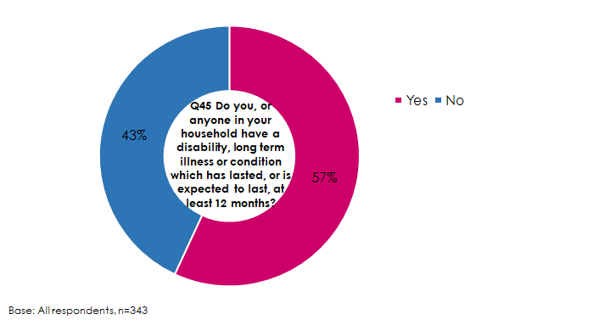
Source BHA/Research Resource Tenant Satisfaction Survey 2022

Based on this limited data, our tenants are more likely to be female. The vast majority are White Scottish and more likely to be middle aged or older people. Our tenants state that they are more likely to have a disability, long term illness or condition that has lasted or is expected last at least 12 months. Most figures are in line with the overall figures for Renfrewshire other than the disability figure which is significantly lower with circa 70% of Renfrewshire residents stating they do not have a disability (Source: Census Data 2011 – this will be reviewed when new data is available – see Action Plan).

We do not currently hold data on the diversity of housing applicants. We will ensure that when we review our housing application software in early 2024 that this is a key component of this service provision. The strategy will be updated in due course to reflect housing applicant data once available.

1.2 Bridgewater Housing Staff

The Association has an equal number of women and men in senior leadership positions but has some level of workforce segregation. For example, almost all higher-grade post holders in Care and Repair roles are male and all members of the Association’s Finance Team are female. The majority of staff are female:

Source: Staff Equalities Data Collection Survey 2023

No staff noted that they considered themselves to be a trans person. The vast majority of staff (97%) noted that they were heterosexual/straight.
All staff who have completed the survey are from white backgrounds. This is a 3% difference on the overall population of Renfrewshire but does show a lack of diversity in the community and the staff base.

Source: Staff Equalities Data Collection Survey 2023

A breakdown of staff religion or belief is shown here:

Source: Staff Equalities Data Collection Survey 2023

The proportion of the staff team with a disability (3%) is significantly lower than in the Renfrewshire population.
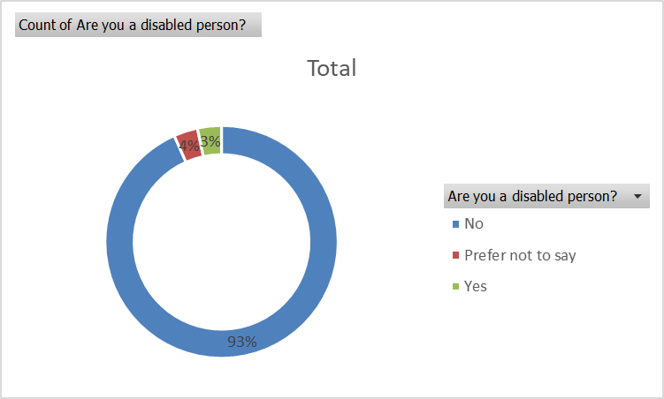
Source: Staff Equalities Data Collection Survey 2023

The Association’s staff team could be described as generally middle aged. It is hoped that the average can be brought down in future years as a result of a proactive approach to employ more apprentices and trainees.

Source: Staff Equalities Data Collection Survey 2023

1.3 BHA Board

Our Board is not fully diverse in terms of age as there is no members under 35, however it is diverse in terms of marriage/civil partnership status and gender. A third of the Board has a disability. The Board is fairly representative of general Renfrewshire communities in terms of ethnic diversity with no Board Members from a minority ethnic group however, this will be reviewed once new Census data is available. Over half the Board are Christian with a third having no religion or belief. Source: Board Equalities Data Collection Survey 2023

Source: Board Equalities Data Collection Survey 2023

Source: Board Equalities Data Collection Survey 2023

Source: Board Equalities Data Collection Survey 2023

Source: Board Equalities Data Collection Survey 2023

Source: Board Equalities Data Collection Survey 2023

Source: Board Equalities Data Collection Survey 2023

1.4 This data will continue to be collected annually and compared to the previous survey results; should there be any notable changes in the statistics this EDI Strategy may be presented for Board to review outwith the normal review cycle.

Appendix 2: Action Plan 2023-2026

Equality, Diversity, and Inclusion Action Plan 2023-26. At BHA we aspire to be sector leading in our approach to equality, diversity, and inclusion. The action plan will be monitored by the Leadership Team and the Finance and Corporate Services Sub-Committee.

EDI goals:
- Ensure that our EDI-related supporting documentation is effective and inclusive
- Develop and nurture an inclusive EDI workplace culture and knowledge/skills-base amongst our staff and Board
- Know our customers - Use EDI data collection to better inform our business decision-making and practices
- Engage with external stakeholders and the wider community to foster an inclusive environment together
- Make our materials and services as accessible as possible to our customers and service users
- Increase inclusivity, encourage greater diversity, and remove barriers within our recruitment and selection practices

EDI Strategic objectives
- Firmly embed EDI into our internal culture and practices by 2026.
- Foster an inclusive culture with all external stakeholders who we come into contact with by 2026.

Equality, Diversity, and Inclusion Action Plan 2023-26. At BHA we aspire to be sector leading in our approach to equality, diversity, and inclusion. The action plan will be monitored by the Leadership Team and the Finance and Corporate Services Sub-Committee.
 | Action | EDI Strategic Objective | EDI Goal | Expected completion date | Action completion date | Person(s) responsible | Comment
 | Approval of Equalities Strategy | 1 | 1 | 06/12/2023 | 06/12/2023 | CEO | 1st Draft
 | Develop action plan and append to Strategy | 1 | 1 | 06/12/2023 | 06/12/2023 | CEO, HOCS | 1st Draft
 | Review EDI Policy and go out to consultation | 1 | 1 | 30/11/2023 | 25/01/2024 | CEO, HOCS | Delayed due to Rent consultation. We will put it out to staff and through email, social media & Portal to our customers.
 | Approval of Equality, Diversity & Inclusion Policy & Strategy | 1 | 1 | 06/03/2024 |  | CEO, HOCS | Final Draft
 | Review of an Equality Impact Assessment Form | 1 | 1 | 31/03/2024 |  | LT | We have a model form through training done will review as part of training with Stephanie Harper. This will be appended to the EDI Policy
 | Training | 1 | 2 | Ongoing |  | HOCS | Create a 3 yearly training and awareness plan. Have it ready by 30/06/2024 (after initial training is concluded).
 | Training: Staff and Board - General Concepts | 1 | 2 | 31/07/2024 |  | HOCS | Will engage with Stephanie Harper to see if she can do 2 x 2-hour session.
 | Training: Staff and Board - Protected Characteristics | 1 | 2 | 31/07/2024 |  | HOCS | Will engage with Stephanie Harper to see if she can do 2 x 2-hour session.
 | Develop a consistent message for all publications. | 2 | 5 | 31/03/2025 |  | HOCS / HOHS | Part of Communication Strategy which is to be developed
 | Develop a 3-year engagement plan with community groups associated with protected characteristics | 2 | 4 | 31/03/2025 |  | HOHS | Tie in with Training and Awareness Plan and Customer Engagement Strategy.
 | Endeavour to use plain language in all our publications | 2 | 5 | Ongoing |  | LT | We will build this into the Communications Strategy
 | Rolling out equalities data collection across all protected characteristics for the following groups: staff, Board Members, job applicants, housing applicants. | 1 | 3 | 31/05/2024 |  | CEO, HOCS | Surveys of tenants, board and staff commenced, update recruitment and applicants. Consider owner-occupier survey.
 | Creating an equalities data set including visual, accessible graphics. Promote this to staff and customers. | 1 | 3 | 30/06/2024 |  | HOF, ICTM
 | Review Census 2022 Data against action plan and carry out mid-term sense check to determine if strategy review should be brought forward | 1 | 3 | 30/06/2025 |  | HOCS
 | Actively assess the equalities data set to identify any potential discrimination, e.g., job applications not translating to new staff or housing applications not translating to offers of housing. | 1 | 3 | 30/10/2024 |  | CEO, HOCS
 | Consider joining and actively participating in the Scottish Federation of Housing Associations Community of Practice on Equality, Diversity, and Inclusion | 2 | 4 | 31/11/2024 |  | CEO, HOCS
 | Actively use the equalities data set as part of the 2024 Business Planning review process. | 1 | 3 | 31/12/2024 |  | CEO
 | Develop a system to proactively collate and use customers’ communications preferences and requirements. | 2 | 5 | 31/03/2025 |  | LT | Linked to overall review of Housing Management Software
 | Consider actively translating key documents. | 2 | 5 | 31/05/2025 |  | CEO, HOCS | Subject to outcome of customer survey
 | Consider whether adaptations are required to void standard and property investment standard specifications to adapt to diverse customer base. | 2 | 5 | 31/12/2024 |  | HOPS | Particular attention to disability levels.
 | Developing a Board recruitment campaign that proactively targets candidates from minority ethnic groups, younger age groups and with disabilities particularly recruitment of members under 35 years of age | 2 | 6 | 31/10/2024 |  | CEO | Subject to vacancies on Board and outcome of customer surveys.
 | Review the Association’s staff recruitment approach including maximising applications from a diverse range of applicants. | 2 | 6 | 31/03/2024 |  | HOCS
 | Consider recruiting a Positive Action Trainee into one of the Operational Teams Housing (PATH) trainee | 2 | 6 | 31/03/2025 |  | CEO, HOCS | Subject to budget and any available funding
 | Consider feasibility of modern apprenticeship programme and graduate apprenticeship roles where appropriate | 2 | 6 | 31/03/2025 |  | CEO, HOCS
 | Deliver a programme of all staff equality, diversity, and human rights training to give staff the confidence to acknowledge their unconscious biases, be inclusive and challenge disadvantage and discrimination. This to include induction and continuous development. | 1 | 2 | 31/07/2024 |  | HOCS
 | Provide and deliver a programme of online bitesize equality and diversity training and resources throughout the year focusing on key issues, such as EDI, neurodiversity, structural or the menopause. | 1 | 2 | 31/10/2024 |  | HOCS | Delivered online ideally
 | Delivering staff wellbeing programme | 1 | 2 | 31/07/2024 |  | HOCS | Engage Seamus Corry and agree relevant programme for staff wellbeing including mental health and disability awareness
 | Partner with third sector groups to deliver at least three events targeted at promoting community inclusion. | 2 | 4 | 31/03/2026 |  | HOHS
 | Ensuring every annual review includes an equality and diversity element | 1 | 3 | 31/10/2024 |  | CEO, HOCS
 | Reaffirm commitment as a “Disability Confident Employer” | 1 | 6 | 31/12/2024 |  | HOCS
 | Consider Leaders in Diversity or Customer Service Excellence accreditation | 1 | 6 | 31/07/2026 |  | CEO
 | Open Communication – actively run campaigns on the individual protected characteristics and Human Rights issues and talk about these within the Association and our communities. | 2 | 4 | Ongoing |  | LT
 | Consider conducting a staff and customer equality, diversity and inclusion survey using Investors in Diversity as basis | 2 | 4 | 31/10/2025 |  | CEO, HOCS
 | Introduce a new online application form system | 2 | 5 | 31/03/2024 |  | HOHS
 | Assess and advise on the negation of Modern Slavery within our supplier chains. | 2 | 4 | 31/10/2025 |  | HOPS
 | Communicate to stakeholders when the next equalities monitoring will be taking place and bring priority areas to their attention as a result of their feedback (e.g., “you said, we did”). | 2 | 4 | 31/10/2024 |  | HOHS / HOCS
 | Introduce new EDI Champions within staff and Board | 1 | 2 | 31/12/2025 |  | LT/ HOCS | 2 members of staff and 1 board at all times ideally
 | Establish Mental Health First Aiders and appropriate training | 1 | 2 | 31/03/2024 |  | LT/HOCS | 2 staff members with allowance as per EVH T&C’s
 | Establish an EDI calendar to celebrate notable events in different cultures | 2 | 5 | 31/07/2025 |  | HOCS / ITCM | Make use of social media to highlight events

